Digital Design: Design Principles Brochure
Directions: You are to create a brochure about Design Principles we have covered in class. You may use your notes, online links, etc for reference. You are to develop a brochure using all of the elements you learned about from the graphic design note taking. Keep these elements in mind as you design your layout, select your fonts and color scheme. Your brochure will be scored on all elements covered, not just the topics you discuss. This Brochure should be informative, providing information about your topic for those who have no knowledge of graphic design or design principles. Create one brochure using a Brochure template in Microsoft Publisher OR using a brochure template on Canva.com.
Publisher Instructions: Open MS Publisher > In the top search bar type “Brochure”. Select the 2nd option “Trifold brochure”. Click Create. You must use your own color scheme, fonts, etc. Delete the current content.
Page 1 Page 2
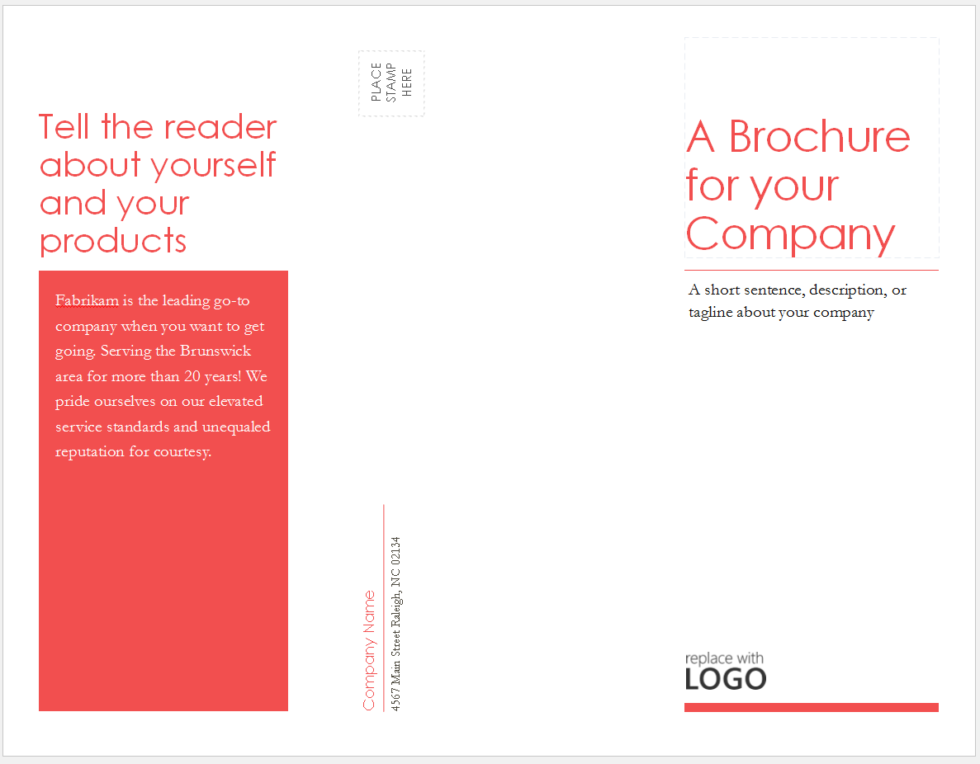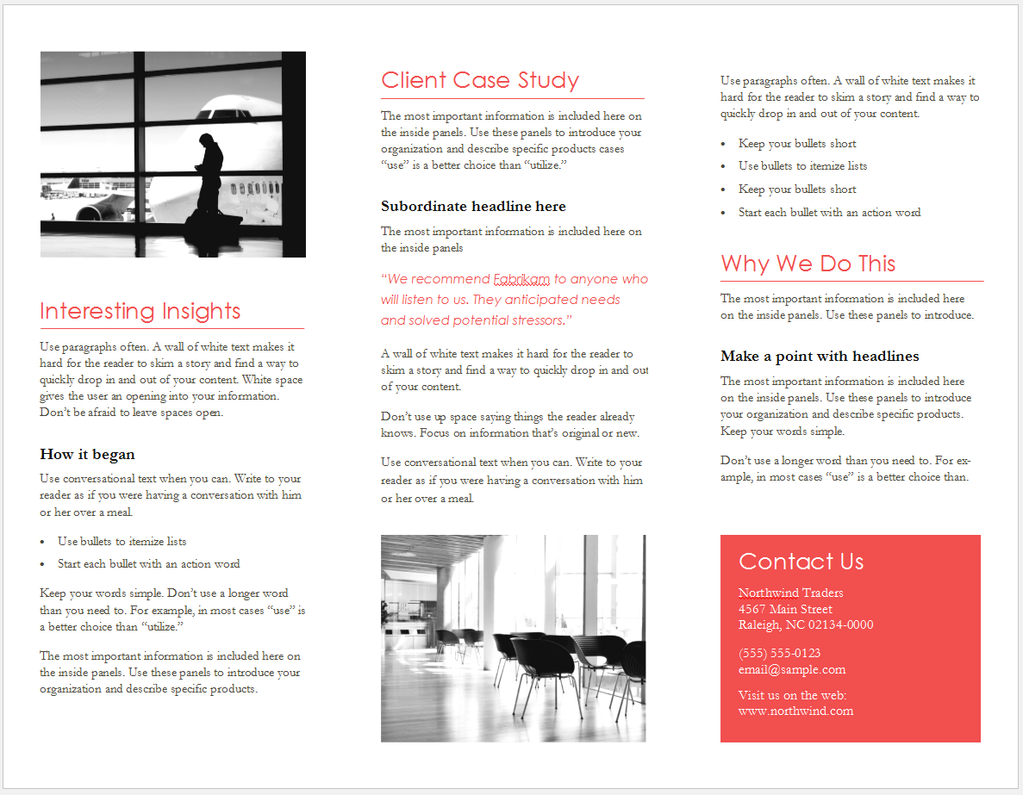
Right
Middle
Left
Inside tab Cover
Back Cover
Front Cover
Canva.com Instructions: Log in to Canva.com. At the top, under Create a design, select “More”. Scroll down to Marketing Materials & select “Brochure”. Select a design and edit the color scheme, layout and design to fit your project.

Rubric: Design Principles
Requirements | Possible Points | Points Earned | Comments
Adequate, appropriate, and correct Content.  Title, name, date, period, (on front cover) etc. | 30
Design Principles:  Layout, Contrast, Alignment, Color, Graphics, Font & Consistency | 60
Mechanics: Spelling, Grammar, Punctuation | 10
Total | 100

