How Photoshop layers works:
What are layers and why are they so useful? You have to think in this way: every composition realized in Photoshop is the result of several layers combined together. So a layer can be defined as the fundamental Photoshop unit.
Let’s create a new document in Photoshop (File>New):
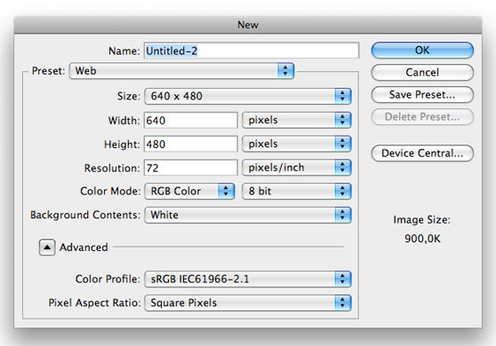
In the bottom right you should have the layers window. In case you don’t see it, go to Window>Layers:
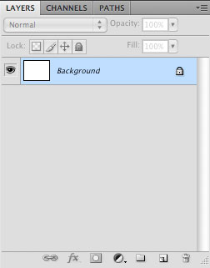
- Here you can visualize, select and modify all the layers that compose your final result. As you may have noticed, in this moment we have a single white filled layer.
- Create a new layer by pressing the appropriate button at the bottom of the layers window.
- Photoshop will automatically create blank layers.

Set the foreground color to black by clicking on the foreground color thumbnail to open the color picker and selecting black (#000000).
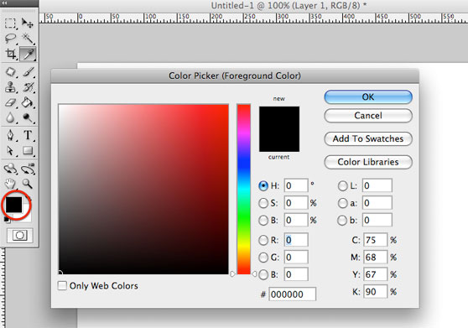
- Now grab the Paint bucket tool and click on the canvas to fill it with black.
- Let’s analyze the layers window: the blank layer is now black. This is because what we do on the canvas affects only the layer which is selected.
- We have 2 layers, one black and one white. Since the black one is above, it’s displayed while the white one is hidden (layer hierarchy)
.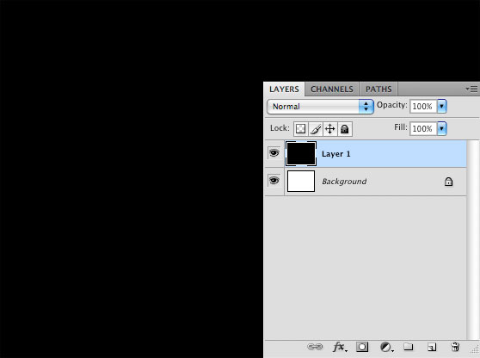

Switch the foreground color to yellow (#f9d904) and use the horizontal type tool (T) to write something. Note that Photoshop has automatically created a new type layer:
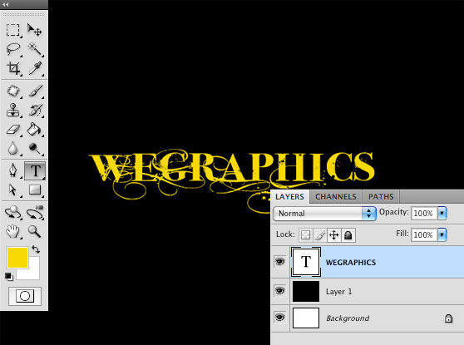
The background layer is locked (note the padlock on the right of the layer thumbnail). This means it can’t be modified. To unlock the background layer double click on it and hit OK in the window that appears:
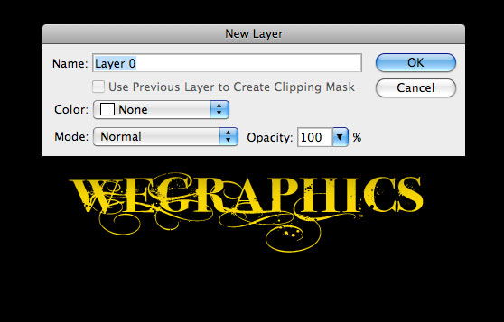
Every time you want to prevent a layer from casual adjustments you can lock it by selecting it from the layers window and pressing the lock button.
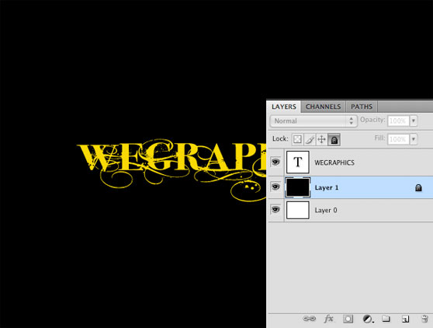
You can give a title to each layer. This is a good practice in particular when you work with complex compositions. Simply double-click on the layer title in the layers window to re-name it.
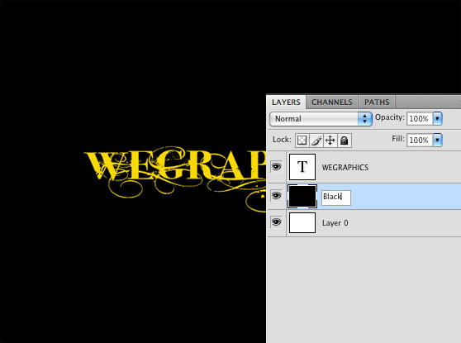
Select the bottom layer (the white one), set the foreground color to orange (#eb6e08), grab the paint bucket tool and click to fill. Apparently nothing has changed but the bottom layer is now filled with orange, as you can notice from the layers window.
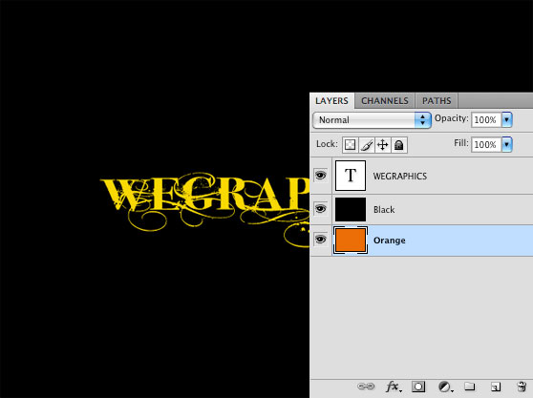
Select the black layer. Grab the eraser tool (E) and select a round 300px brush:
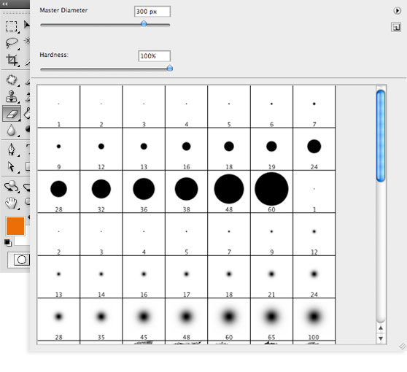
Click once in the center of the canvas. What happens? Once erased the center of the black layer, a part of the orange one appears.
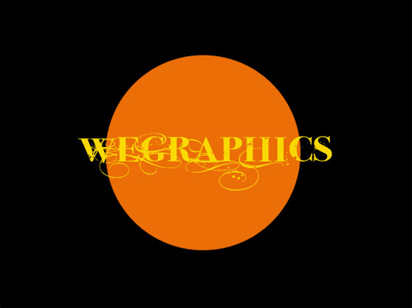
This is due to layers hierarchy:
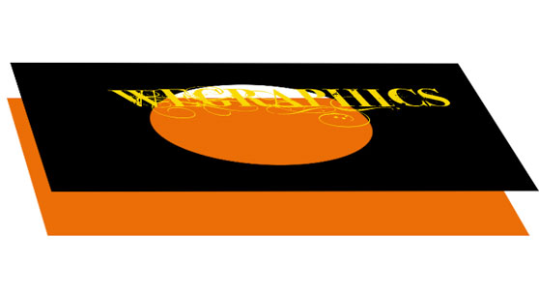
In the layers window move the text layer below the black one:
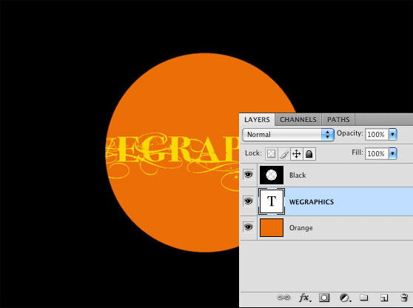
- Right-click on the layers thumbnail and select Blending options. Here we can add some adjustments to the layer. Select “drop shadow” with the following settings (screenshot). In this way we can add depth to the image:
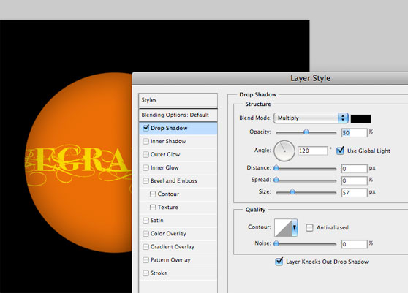
- You can add a soft shadow to the text too. In this way you can feel more the sensation to work with 3 different levels one on the top of the other.
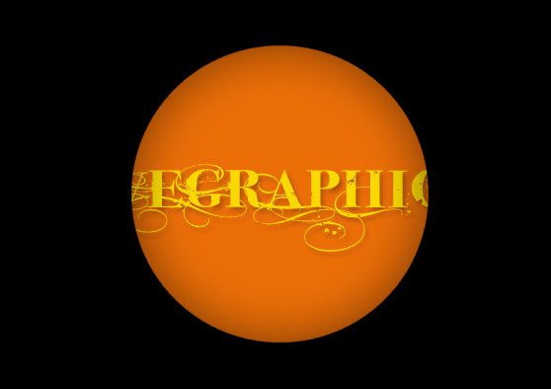

Why are layers so useful?
In this mini-exercise I want to show you the usefulness that derives from a correct use of layers. Create a new document in Photoshop with a white background and unlock the background layer as we did in the previous tutorial. Grab the brush tool and paint over the canvas:
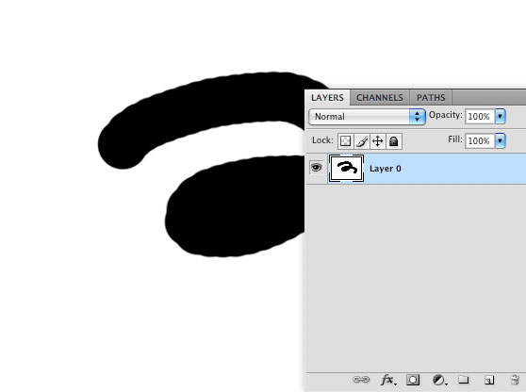
What does happen if you want to move the brush effect? You’re obliged to move the entire image (brush+white background):
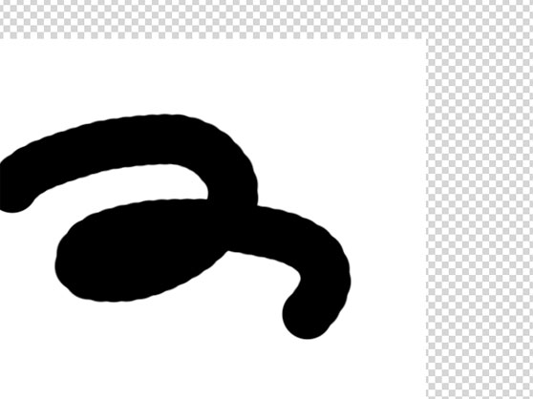
Let’s go back. Instead of painting directly on the white canvas, create a new layer and paint over it:
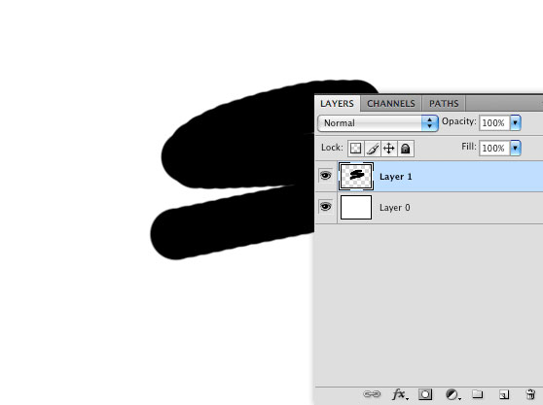
Seemingly the result doesn’t change. But this time if we try to move only the brush effect…ta daaaaaaa! We can! Because we affect only the layer that contains brushes. So this is the essence of the speech: layers can give you full control on your works. In particular if properly used they allow you to modify any detail of the composition at any moment (full control!). And this is fundamental when you are working on projects composed by 100-200 layers. Always try to create a new layer for every important modification.

Activity
You are to create a new Photoshop file. Edit the background color to your choice. Create additional layers. One layer must include your name. Add additional content to the third layer. You must choose how to show the content in the third layer. All three layers must be visible in final version. Save in your Photoshop folder as “Layer Practice”.

