IDT: Operating System Brochure
Directions: Research Windows, Mac, iOS, and Android operating systems. Identify information about the Operating System and 3 advantages and 3 disadvantages for each operating system. You are to develop an informational brochure about these Operating Systems. You are to use Canva.com (log in with your gmail or create an account). Once Logged in, select the “Create a Design” option on the top left. Scroll to the Marketing Materials section & select the “Trifold Brochure” template. Select a layout from the left (The layout you select should reflect a business type theme…no food or nature backgrounds). The brochure will include the following:
Title Panel: “Operating Systems”, your name, date, and period.
Back Panel: Heading- “Which OS would I choose?” Identify which OS you would prefer for desktop and mobile devices. Explain why you made this decision for each.
Inside Flap: Windows Information
Left Panel: Mac Information
Middle Panel: Android Information
Right Panel: iOS Information
You must incorporate graphics and make your brochure visually appealing. Download this in your project folder as OS BrochureLastName.

*Remember, start with researching the operating systems first.*
Requirements | Possible Points | Points Earned | Comments
Correct title info | 10
Content for each OS | 20
Incorporate Images | 10
Mechanics: Grammar, Spelling, Punctuation, etc. | 10
Total: | 50

*Instructions for Publisher & Canva are on the back of this paper*
Publisher Instructions: Open MS Publisher > In the top search bar type “Brochure”. Select the 2nd option “Trifold brochure”. Click Create. You must use your own color scheme, fonts, etc. Delete the current content.
Page 1 Page 2
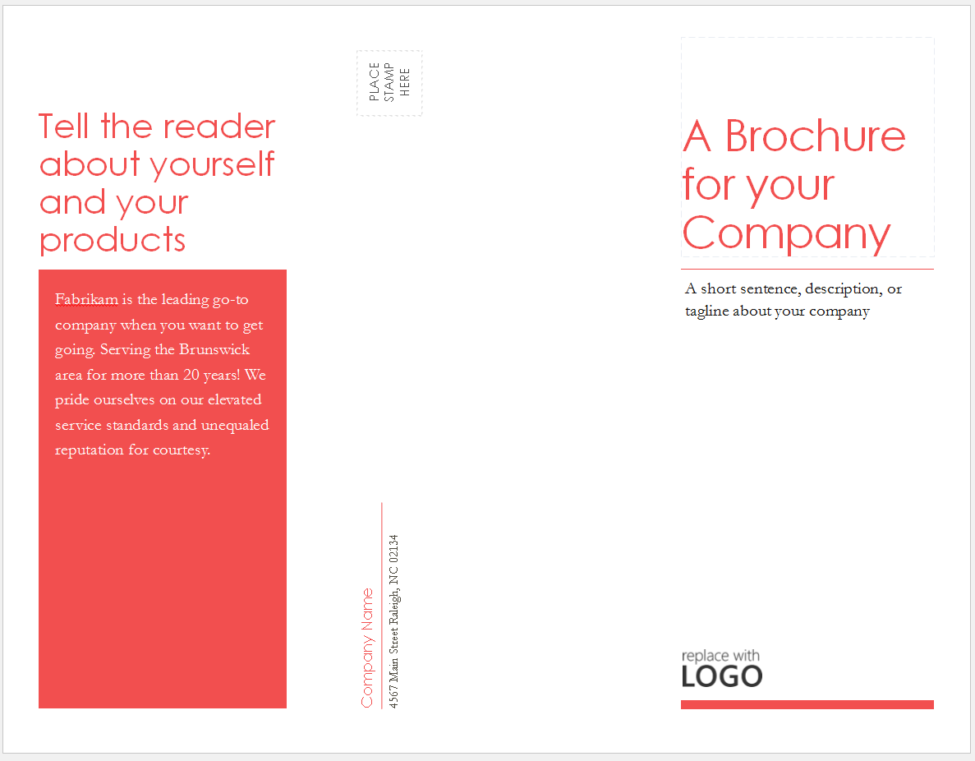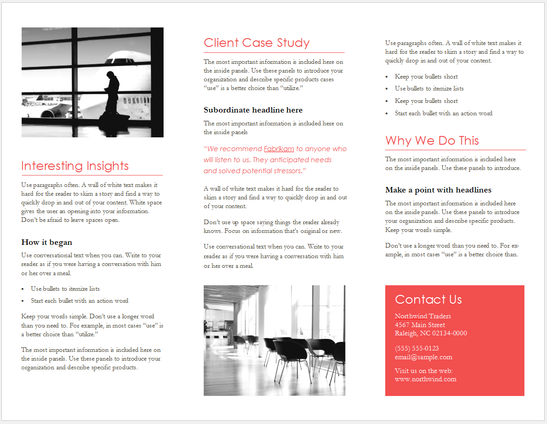
Right
Middle
Left
Inside tab Cover
Back Cover
Front Cover
Canva.com Instructions: Log in to Canva.com. At the top, under Create a design, select “More”. Scroll down to Marketing Materials & select “Brochure”. Select a design and edit the color scheme, layout and design to fit your project.

